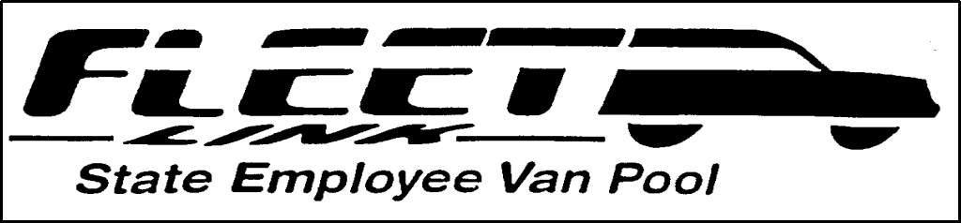

FLEET LINK
Prospective Rider Information

Date:
Name:
Home Address:
Home Phone:

Work Phone:
Department:
Division:
Work Location:
Work Hours:
Comments:

Return completed form to:

Fleet Link Coordinator Fleet Link
D100
Ph:302-857-4533

Revised 06-30-2023

