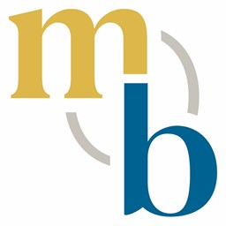
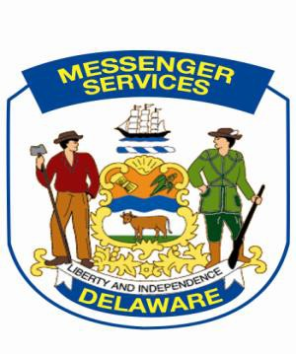
Government Support Services
MESSENGER SERVICES SECTION
100 Enterprise Place, Suite 4
Dover DE 19904 SLC- D100
Phone: 302-857-4571
Fax: 302-739-3697
matthew.sammons@state.de.us
MESSENGER SERVICES SECTION
100 Enterprise Place, Suite 4
Dover DE 19904 SLC- D100
Phone: 302-857-4500
Fax: 302-739-3697
dustin.yerkes@state.de.us

MESSENGER SERVICES SECTION
100 Enterprise Place, Suite 4
Dover DE 19904 SLC- D100
Phone: 302-857-4500
Fax: 302-739-3697
michael.russo@delaware.gov

STATE OF DELAWARE AGENCY CONTACT PERSON

Date: February 16, 2022

Please complete the below information as it pertains to your department. This information is necessary for Messenger Services to have when contacting state agencies for emergencies, interruption of mail service, issues concerning USPS and interdepartmental mail, SLC codes and billing information.

Please contact Michael Russo should you need assistance with any mailing issues. Contact number is 857-4500; email michael.russo@delaware.gov

State of Delaware Agency Department:
Agency State DDS Billing Code (if applicable):
SLC Code:
Primary Contact:
Contact Number:
Secondary Contact:
Contact Number:
Agency’s Designated Mail Contact:
Contact Number:
(Please disregard if information requested is same as contact person above)
Designated Fiscal Officer Responsible for Postage billing information:
Name:
Contact Number:

Thank you for your continued support and assistance. Messenger Services continuously seeks the opportunity to create a lasting relationship of service and partnership with your agency, our valued customer.

Please return this completed form via email to: michael.russo@delaware.gov

