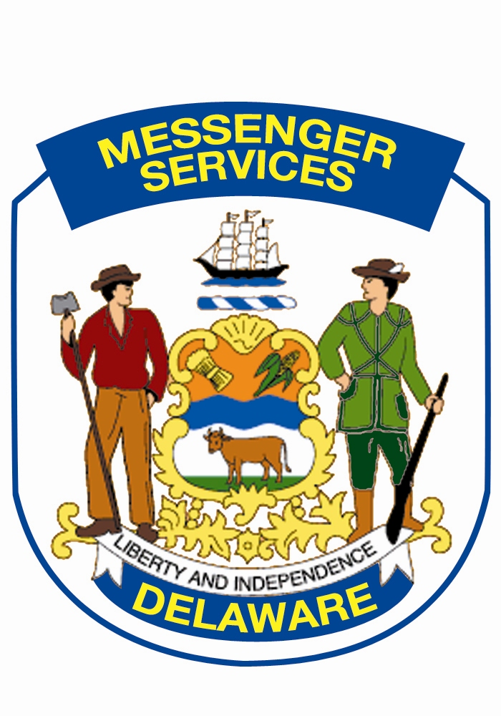

Government Support Services
MESSENGER SERVICES SECTION
100 Enterprise Place, Suite 4
Dover DE 19904
SLC- D100
Phone: 302-857-4500
Fax: 302-739-3697
Michael.russo@delaware.gov

REQUEST FOR MAIL SERVICE

Form must be submitted at least 2 weeks prior to service start date
Submit form via e-mail to: michael.russo@delaware.gov

Service requested:
USPS Mail Pickup / Delivery Please complete sections I & II

Metering Service Please complete sections I &III

Interdepartmental Mail Pickup / Delivery Please complete sections I & II

Section I:
Dept: Title:
Division: Phone:
Section: Fax:

Primary Contact Name & Phone Number:

Secondary Contact Name & Phone Number:

Primary Fiscal Contact Name & Phone Number:

Section II:

Location of stop:
Does your agency/office presently utilize any type of internal delivery service between offices: Yes No?
Estimated number of mail pieces your office generates per day: Interdepartmental
Metered
* All agencies receive one pick up & delivery per day
Section III:

Location of stop:

Does your office presently have its own postage machine: Yes No?
If yes, please complete the following:
Postage Meter Model:
Postage Used Monthly:
Monthly Meter Rental fee:
Annual Maintenance fee:
Is Postage Machine: Owned Leased?
If leased, please provide exportation date of lease.

FOR MESSENGER SERVICES USE ONLY
Date:
Approved
Denied

Reason for denial:

__________________________________________________________
Manager – Messenger Services

______________________________________________
Director - Government Support Services

