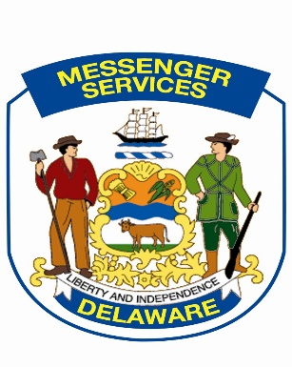

Government Support Services
MESSENGER SERVICES SECTION
600A South Bay Road
Dover DE 19901
SLC: D100
Phone: 302-857-4500
Fax: 302-739-3697
Michael.russo@delaware.gov

Agency Relocation Request for Mail Service

Form must be submitted at least 2 weeks prior to office relocation
Submit form via e-mail to: michael.russo@delaware.gov

SECTION I:
Date: February 25, 2026 Requested by:
Dept: Title:
Division: Phone:
SLC: Fax:

SECTION II: Contact Information
Current Primary Contact Name & Phone Number:
Current Secondary Contact Name & Phone Number:
Current Fiscal Contact Name & Phone Number:

New Location Primary Contact Name & Phone Number:
New Location Secondary Contact Name & Phone Number:
New Location Fiscal Contact Name & Phone Number:

SECTION III: Location
Address of current mail stop:

Address of new location mail stop:

Is this a whole agency move: Yes No?
If no, will new SLC code be requested: Yes No?

Effective date of relocation: *
- If entire agency is moving, last mail pick up / delivery will be the working day prior to this date

Will your agency require that your mail be held during the relocation process: Yes No
If yes: Begin date: End date:

If your current location does not receive metering services for USPS mail, but would like to request this service at the new location, please complete a “Request for Mail service Form” which is additionally required.

Justification for this request:

If any of the above information changes prior to your relocation date, you must contact us immediately at the above email address in order to update submitted information.

FOR MESSENGER SERVICES USE ONLY
Date:
Approved
Denied

Reason for denial:

__________________________________________________________
Manager – Messenger Services

CC Director of Operations – Government Support Services

