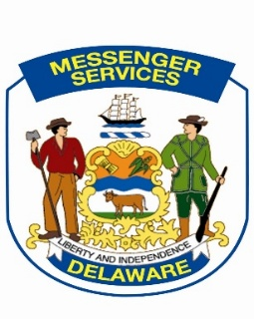


Returned Incorrect Interdepartmental Mail

Messenger Services sorts interdepartmental mail according to the SLC code assigned to each mail piece. In the event you receive incorrect interdepartmental mail, please attach this completed form to any mail piece your agency is returning. Thank you.

Reason for Return

Correct SLC code on envelope, wrong agency location.
Please return to: ______________________________________________

Person named unknown.

Person no longer employed with this agency.

SLC code corrected, please forward.

SLC code unknown;
Please return to: ______________________________________________

Thank you for you assistance. Should you have any question please contact Messenger Services at (302) 857-4571.

